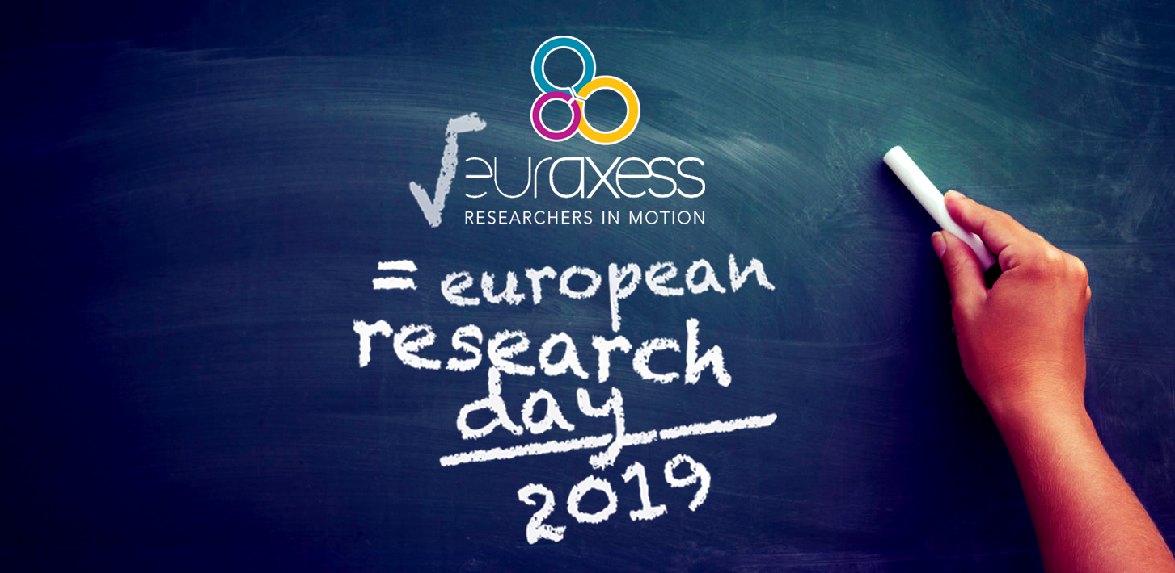

European Research Day 2019

“Europe – Open to the World”

29 October 2019

08.30 – 16.15

Fairfield by Marriott Hotel
Surabaya, Indonesia

What is this event?
This is your chance to meet representatives of leading European research and funding agencies. This one-day event sees presentations by representatives of leading research organizations and funding agencies from across Europe about the variety of fellowship and mobility schemes open to researchers in Indonesia. The programme also includes hands-on advice from expert speakers and invited alumni of various European programmes.

Who should attend?
Researchers (PhD and Postdoc) from all disciplines and all nationalities. Innovative companies. Representatives from university research support offices and international relations offices

When and where is it?
08.30 – 16:15, Tuesday 29 October 2019
Fairfield by Marriott Hotel
3rd Floor Ballroom
Jl. Mayjen Sungkono No.178
Surabaya

How much it is?
Free of Charge!

Do I need to register?
Yes, registration is required. Please register as soon as you can, as seating is limited. Register here

Questions?
Please e-mail: simon.grimley@euraxess.net

08:30 | Registration
09:00 | Welcome Remarks
09:10 | Keynote Address - “Mobility as a Key to Scientific Success”  Prof Sangkot Marzuki, former President of the Indonesian Academy of Sciences, and Director of the Eijkman Institute for Molecular Biology
09:30 | How I Advanced my Research Career in Europe – alumni of European funding programmes share their experience – panel discussion
10:15 | Coffee Break
10.30 | Research Funding Opportunities in the Netherlands  Mr Peter van Tuijl, Director, Nuffic-Neso Indonesia
10.50 | Research Funding Opportunities in the UK – Newton Fund  Ms Triny Tresnawulan, Programme Manager, Research and innovation, British Embassy
11.10 | Research Funding Opportunities in France  Mr Thierry Maré, Attaché de coopération scientifique et technologique  Institut français d’Indonésie, \Ambassade de France en Indonésie
11.30 | Research Funding Opportunities in Spain  Ms Sofia Lopez Navarro, Deputy Directorate of Technology Cooperation, CDTI
11.50 | Research Funding Opportunities in Germany  Mr Christian Rabl, Deputy Director, DAAD Regional Office Jakarta
12.10 | Advancing your Research in Europe with EURAXESS  Mr Simon Grimley, Regional Representative, EURAXESS ASEAN
12.30 | Lunch Break
13.30 | How to Find a European Partner – Panel Discussion
14.20 | Marie Sklodowska-Curie Actions (MSCA)  Mr Jean-Marie Pincemin  France National Contact Point for the Marie Sklodowska-Curie Actions
14.40 | Testimonials from MSCA fellows
15.00 | Coffee Break
15.20 | Southeast Asia-Europe Joint Funding Scheme for Research and Innovation  Dr Teguh Rahardjo, Executive Director, Indonesia Science Fund
15.40 | Closing Remarks - EU Delegation to Indonesia and Brunei Darussalam  Mr. Charles-Michel Geurts, Deputy Head of the European Union Delegation to Indonesia and Brunei Darussalam
15:50 | Networking with Presenters
16.15 | End
